**CHAPTER 1**

**INTRODUCTION**

**1.1 Problem Statement**

The rapidly growing population is to blame for the highest level of waste generation ever. In 2020, it was predicted that 2.29 billion tonnes of garbage would be produced, or 0.79 kg per person each day. By 2050, this amount is projected to rise by 73% to 3.88 billion tonnes as a result of population growth and increasing industrialization[1]. Due to the rise in trash generation, waste segregation has become a very laborious and challenging process. This process is typically carried out manually with the aid of human intelligence and physical work.

There are numerous types of waste, including paper, metal, plastic, food scraps, industrial waste, and others. Every piece of garbage needs to be accurately classified into different types since each type requires a different processing method. Various categories, including dry and wet garbage, recyclable and non-recyclable waste, biodegradable and non-biodegradable waste, etc., are used by modern systems to classify rubbish. Although some level of segregation is permitted under this classification, it is insufficient to properly handle the rubbish.

Even though the public is becoming more aware of the necessity to separate waste, some items can be confusing during the process and result in inaccurate classification[2]. Since wrongly segregated waste cannot be recycled or disposed of using techniques that work for other types of rubbish, faulty waste segregation is another major issue. This could cause a large financial loss because the recyclable parts of the poorly divided rubbish cannot be recovered. Incorrectly categorized trash at landfills can have an effect on both the natural world and people's lives. Landfills produce greenhouse gasses that are bad for the environment[3].

**1.2 Objectives and Proposed Work**

For a long time, waste segregation and management have had a significant impact on a major fraction of the ecosystem. Waste management will be facilitated when technology is used correctly. There are various works and references where the above problem has been considered. However, no matter what techniques were added, it was tough to break through the 80% threshold with the scratch model. This finding prompts us to suggest an InceptionNet-inspired deep convolutional neural network design, in which depth-separable convolutions are used in place of the InceptionNet's Inception modules. (XceptionNet)[4] that divides the waste into 12 different kinds using a dataset of more than 15000 photos and a mobile application.

For the task of classifying our garbage into categories, we earlier proposed to use the Xception Architecture by Google Research[4]

1. XceptionNet

Convolution layers that are distinct from one another in terms of their depth are crucial components of the Xception concept. It is feasible to draw a distinct line within this architecture between the mapping of cross-channel connections and spatial connections in convolutional neural network property maps. This distinction can be made with regard to convolutional neural network property maps. The property extraction basis of the network of Xception, which is a more powerful version of the fundamental architecture of Inception, is made up of thirty-six convolutional layers. Xception is a more recent advancement in the field of artificial intelligence. Except for the very first and very last modules, each convolutional layer comprises a total of fourteen individual modules. The exceptions to this rule are the very first and very last modules. Each module is surrounded on all sides by corresponding linear remnants that run in a circle around it. Because it is a linear heap of depth-wise separable convolution layers with residual relations, this architecture is especially simple to explain and alter [4]. This is owing to the fact that it has residual relations.

Now, we continue our research on a few novel implementations that are both compatible with the project and untested in order to make our study stand out. They consist of EfficientNet, MobileNet, and XceptionNet.

1. MobileNet

For use on mobile and embedded devices, a convolutional neural network architecture known as MobileNet was developed at Google. It was developed by Menglong Zhu, Bo Chen, Dmitry Kalenichenko, Weijun Wang, Tobias Weyand, Marco Andreetto, and Hartwig Adam.

MobileNet uses depthwise separable convolution, a type of convolutional procedure that splits the standard convolution operation into two steps: a depthwise convolution and a pointwise convolution. The depthwise convolution applies a single filter to each input channel separately, as opposed to the pointwise convolution, which applies a 1x1 filter to combine the output channels of the depthwise convolution.

By using this technique, MobileNet can reduce the number of parameters and computations while still maintaining a high level of accuracy. In mobile devices and in embedded systems, it has been extensively employed for computer vision tasks like object identification, image classification, and other computer vision tasks. Here is a simplified version of a complex MobileNet architecture :

Input Image

|

Convolution (3x3, stride 2)

|

Batch Normalization

|

ReLU Activation

|

Depthwise Convolution (3x3, depth multiplier 1, stride 1)

|

Batch Normalization

|

ReLU Activation

|

Pointwise Convolution (1x1, stride 1)

|

Batch Normalization

|

ReLU Activation

|

Depthwise Convolution (3x3, depth multiplier 1, stride 2)

|

Batch Normalization

|

ReLU Activation

|

Pointwise Convolution (1x1, stride 1)

|

Batch Normalization

|

ReLU Activation

|

...

|

Depthwise Convolution (3x3, depth multiplier 1, stride s)

|

Batch Normalization

|

ReLU Activation

|

Pointwise Convolution (1x1, stride 1)

|

Batch Normalization

|

ReLU Activation

|

Global Average Pooling

|

Fully Connected Layer

|

Softmax Activation

|

Output (Class Probabilities)

**1.3 Software Requirements Specification**

1. User Interfaces
   1. Frontend Software - Flutter Framework

Google created the Flutter mobile app development framework. With a single codebase, it enables developers to create robust, cross-platform mobile applications for iOS and Android. Flutter offers a wide range of pre-built widgets and tools for designing stunning and engaging user interfaces. It leverages the Dart programming language.

Flutter's "hot reload" feature, which enables developers to see changes to their code in real-time without having to restart the app, is one of its primary advantages. This can significantly expedite the development process and aid developers in making quick iterations.

Flutter is a great option for creating aesthetically appealing mobile applications because it also comes with a robust set of tools and libraries for designing complicated animations and visuals.

* 1. Backend Software - Kaggle (Dataset and Train), Google Cloud Platform, API

Kaggle is a data science and machine learning platform that provides a community for data scientists, researchers, and practitioners to collaborate, compete, and learn. It was founded in 2010 and acquired by Google in 2017.

On Kaggle, users can find a wide variety of datasets, tools, and resources for data analysis, machine learning, and deep learning. They can also participate in competitions, where they can test their skills by building and submitting models to solve real-world problems and win prizes. Competitions cover a wide range of topics, such as image classification, natural language processing, and prediction modeling.

Kaggle also offers a platform for hosting and sharing data science projects, notebooks, and tutorials. Users can collaborate with others, share their work, and receive feedback from the community.

Google Cloud Platform (GCP) is a suite of cloud computing services provided by Google. It offers a wide range of services for computing, storage, networking, and data analytics, among others. GCP is known for its scalability, security, and reliability, and has been used by many organizations and companies for their cloud computing needs. It also offers a free trial and pricing options based on usage, making it accessible to developers and businesses of all sizes. Some of the most popular GCP services include:

* App Engine: A platform-as-a-service (PaaS) that enables developers to build and deploy web and mobile applications in the cloud.
* Cloud Storage: A service that provides scalable, secure, and durable object storage for data in the cloud.

1. Hardware Interfaces
   1. Android Operating System
   2. Support for Internet Connectivity
   3. Support for Camera
2. Software Interface
   1. Operating System - It works on Android-based devices with a future possibility to run on iOS devices as well.
   2. Connectivity - It requires an internet connection for URL-based features in the mobile application but doesn’t require the same for the main image classification.
   3. Camera - It needs access to the camera and device image storage to capture/upload it to the application.
3. Communication Interface

It supports all types of Android-based mobile devices having a camera built and an android version of a minimum of 4 and above. Our interface is an essential component that defines the structure and behavior of our implementation to segregate waste by use of a input image.

**CHAPTER 2**

**LITERATURE SURVEY**

**2.1 Literature Review**

We looked at a lot of different works and put together a complete summary of all the research that had been done on the subject. We looked at surveys, academic articles, books, and other sources that were relevant to our topic. The above review enumerates, evaluates objectively, and clarifies this prior research. It provides a theoretical foundation for the research and aided us in determining the nature of our investigation. We acknowledge the work of previous researchers, ensuring that our work is well-conceived by reading, evaluating, and incorporating their work into our own. Our goal is to communicate the established knowledge and ideas on a topic, as well as their strengths and weaknesses.

This literature review is intended to provide a critical overview of the present state of research on a certain issue, and it addresses the following:

* Identifies prior research areas.
* Puts each source within the context of its contribution.
* Describes the relationship between each source and the others we have chosen.
* Identifies novel ways to interpret prior research and sheds light on any omissions.

The 2016 TechCrunch Disrupt Hackathon entry "Auto-Trash" has the most similarities to this study [5]. The idea was an auto-sorting trash can with a camera and Raspberry Pi-powered module that could distinguish between compost and recycling. Utilizing Google's TensorFlow, Auto-Trash was expertly built [5]. Their system's flaw was that it could only distinguish between compost materials. When studying the mobile application for android and ios devices, we discovered a project that is similar. This study's objective was to approximately categorize large heaps of trash shown in a picture. The main aim of the mobile application is to allow users to track down and report trash they notice in their neighborhood. The dataset was built by using Bing Image Search, and they trained their network using the photos that were returned [6].

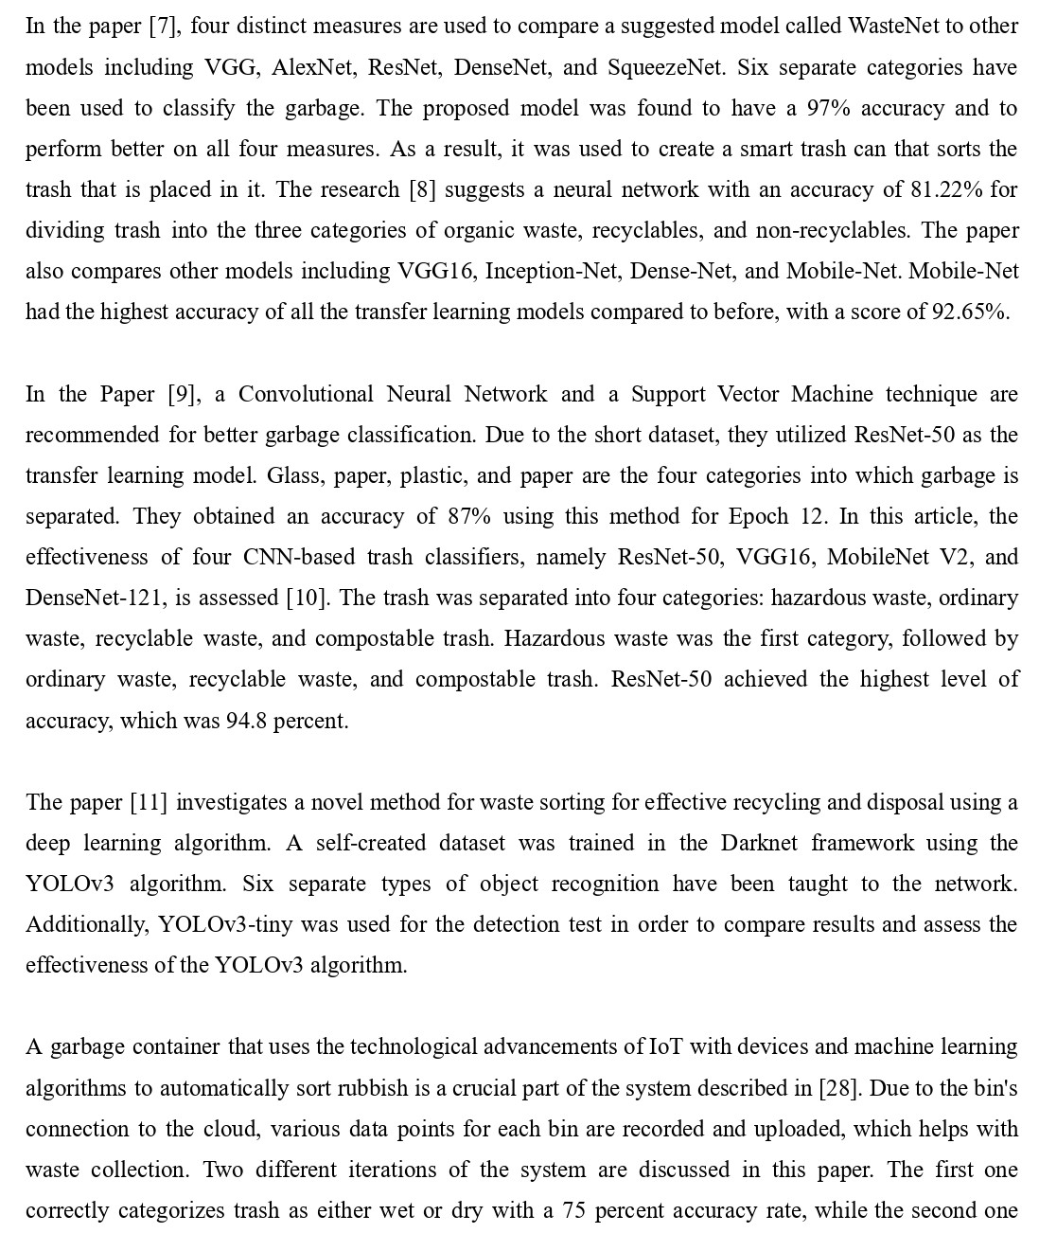

correctly divides trash into six different categories with a 90 percent accuracy rate. Waste was divided by the report's authors [29] into four independent categories: cardboard, paper, metal, and plastic. For photos with a resolution of 50 by 50 pixels, they developed a convolutional neural network that, after 100 iterations, had the best testing accuracy of 76%.

The image classification process typically involves preprocessing the input image, extracting features using convolutional layers, reducing the feature map size using pooling layers, flattening the features into a vector, passing the features through fully connected layers with activation functions, and producing the final output layer with the predicted class label. CNNs are designed to automatically extract and learn features from input images by using convolutional layers, pooling layers, and fully connected layers.

**2.2 Comparison of Existing Methods**

We have compared a number of works containing topics or concepts relevant to our project. It was helpful to plan, develop, and compose a comparative analysis of the entire corpus by focusing on different aspects of these papers.

| **Approach and Algorithm** | **Accuracy** | **Notable Achievements** | **Remarks** |
| --- | --- | --- | --- |
| Comparison between VGG 16, ResNet, AlexNet[3] | 94.9 % (ResNet-50) | 25,077 images were used in the dataset  Compilation of various techniques over the years | Segregation based on only 2 categories - Organic and Recyclable |
| CNN with last 2 layers replaced by a classifier (softmax or SVM)[23] | 79.94 %  (AlexNet with SVM as the last layer) | Clear and simple implementation of only 2 methods  Less computation power required | Categories are limited to 6  Sample size of the dataset is only 2527 |
| InceptionNet Neural Network Architecture using a Real-time embedded system[24] | 96.2 %  (Inception Net) | Implemented hardware solution consisting of Raspberry Pi, IR sensor and PI Camera | Only 6 classes are used to categorize garbage |
| Zero-Shot Learning and Object Detection Algorithms[25] | 83.60 % (YOLOv3) | Unique approach to task  Algorithm mentioned clearly with plans of proposed system | Focus on Object Detection rather than classification  Trained on COCO Dataset |
| Improvement on InceptionNet[4] | ------ | On a larger image classification dataset with 350 million images and 17,000 classes, XceptionNet performs much better than the traditional Inception Net | Better use of model parameters, not more capacity, is what led to the performance gains. |
| SVM with SIFT features  CNN with Torch7 framework[27] | 63 % (SVM) | Use of a simpler algorithm as SVM  Implemented an eleven layer  CNN that is very similar to AlexNet | Small dataset of 2527 images  DIfferentiated on the basis of 6 classes |
| Inception Resnet V2, Xception architectures[26] | 94 % (Inception Resnet V2) | Adam and Adadelta were used as the optimizer in neural network models | Limited samples of the Trashnet dataset |

Table 2.1 Comparison of Existing Approaches

**CHAPTER 3**

**SYSTEM ARCHITECTURE AND DESIGN**

**3.1 Diagrams**

A good diagram provides a concise overview of a system. We can see at a glance which building blocks are being implemented, how they are connected, and how data flows among them. It will be useful in a variety of situations and promote a unified understanding of a system. It can be used to evaluate the system's design.

We have made an architectural and flow diagram to represent the process and structure of the system. It is to demonstrate how objects interact with one another and in what order. It is essential to note that they depict interactions for a specific scenario. The processes are depicted in a rectangular box with arrows representing their interactions.

**3.1.1 ARCHITECTURE DIAGRAM**

An architectural diagram is a picture that shows how the parts of a software system are physically put together. It shows how the software system is put together as a whole, as well as the connections, limits, and boundaries between each part. The diagram provides an overview of the system, allowing users to comprehend how the system's various components interact and to assess the impact of updates and new features.

A simple architecture diagram assists system designers and developers in visualizing the high-level structure of their system or application in order to ensure that it meets the needs of the users. It can also be used to describe the patterns implemented throughout the design. Similar to a blueprint, we used our simple architecture diagram as a guide to discuss and enhance our product with ease.

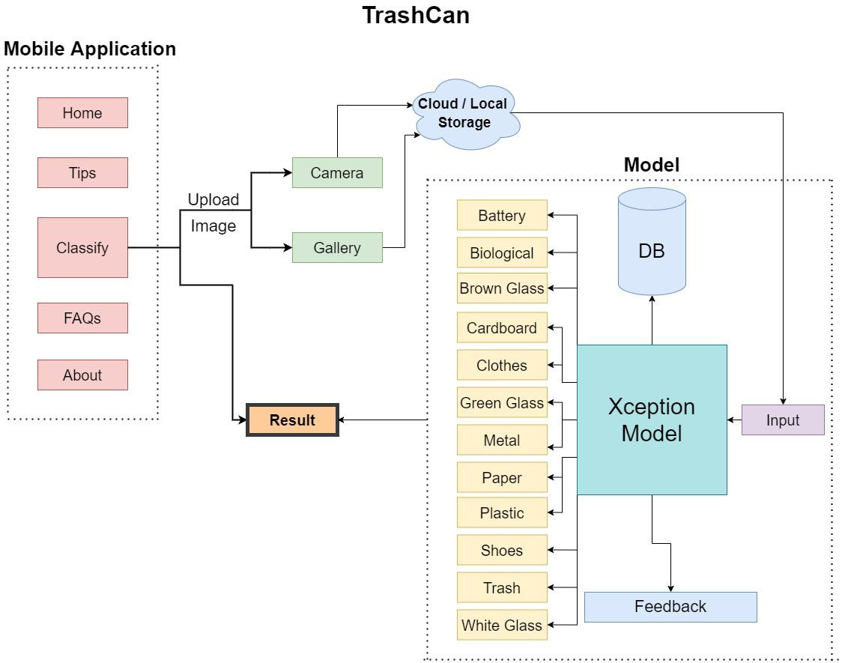

Figure 3.1 Architecture Diagram

**3.1.2 FLOW DIAGRAM**

A flow diagram is a visual representation of a series of actions, system movements, and/or decision points. They are a comprehensive explanation of each step in a procedure, regardless of its complexity. Flow diagrams, which are also called flowcharts, are useful tools for improving how people, things, or information move through a system or process. The meaning of a flow diagram is based on how the diagram's lines and symbols work together to show the direction of a movement and what needs to be done to make it happen.

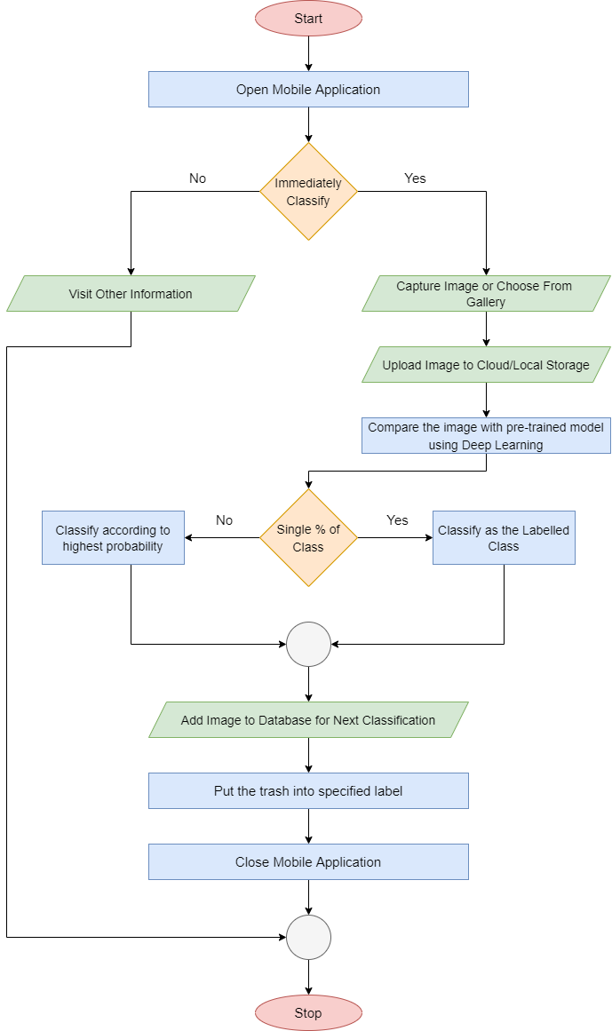

Figure 3.2 Flow diagram

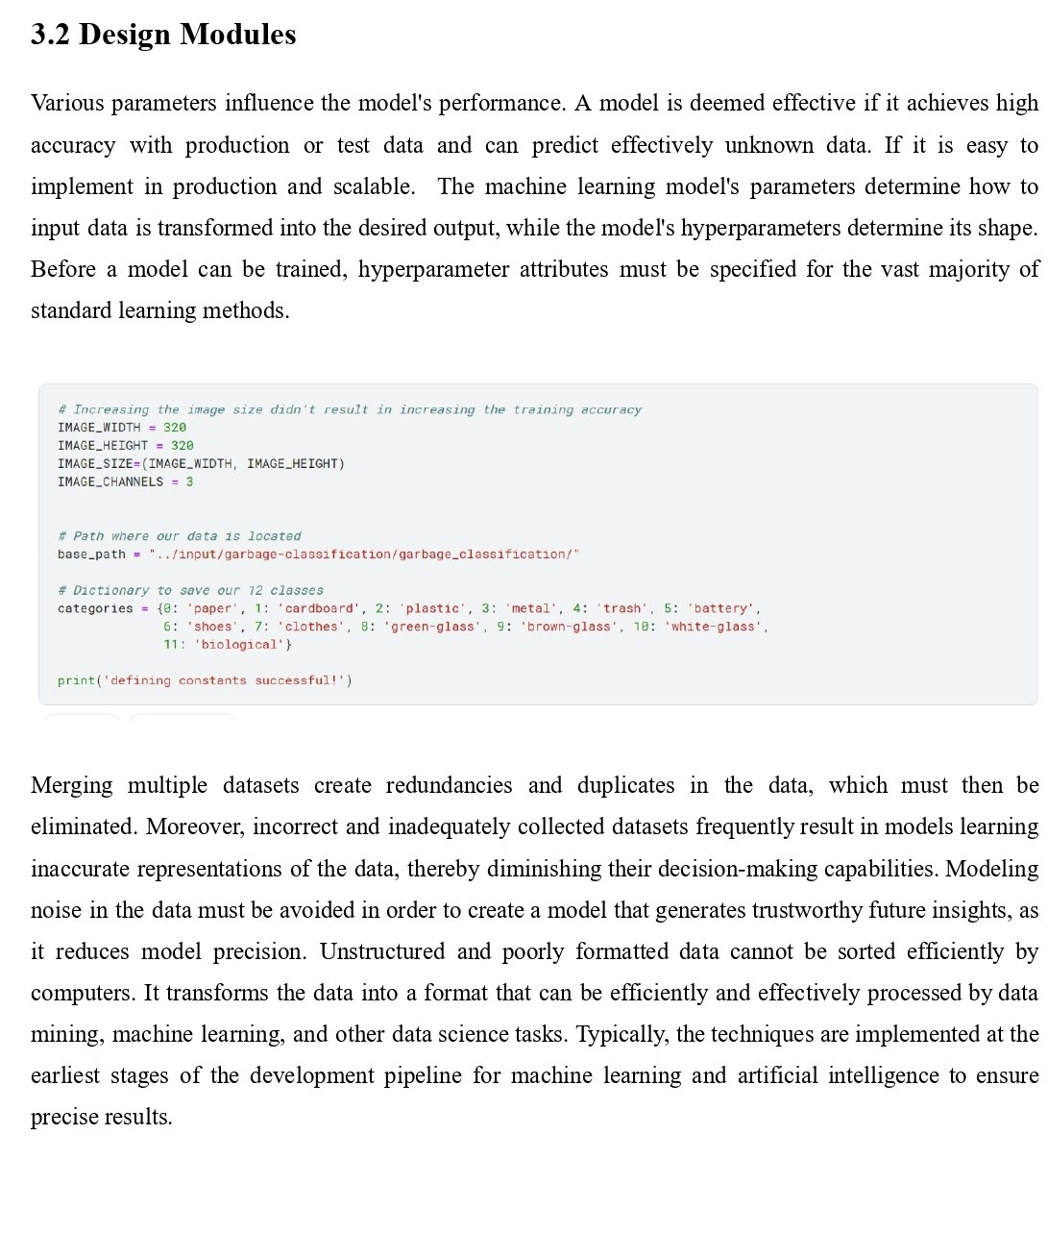

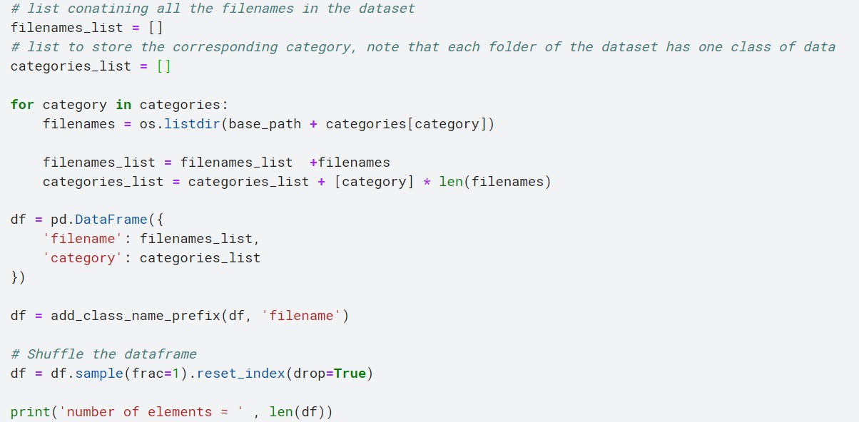

Data visualization is a technique that employs a variety of static and dynamic visuals within a specific context to assist individuals in comprehending and making sense of vast amounts of data. Frequently, the data is presented in a narrative format that highlights patterns, trends, and correlations that might otherwise go unnoticed. Data as a product is frequently monetized through the use of data visualization. Algorithms learn and automate data recognition and pattern identification, resulting in predictive analysis, through machine learning. Machine learning saves time and improves data quality because it employs algorithms to acknowledge and store data patterns. It's not just about tracking the user's data; it's also about understanding the user on a more granular level and how they will engage most effectively. It engenders a higher level of confidence among decision-makers and stakeholders.

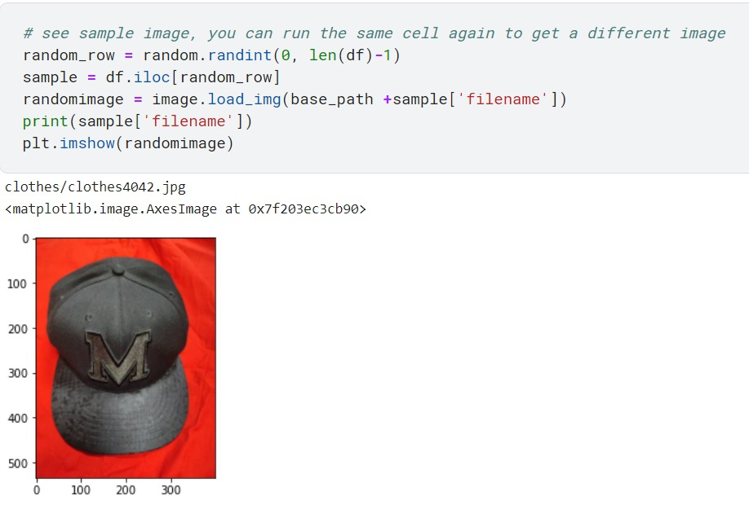

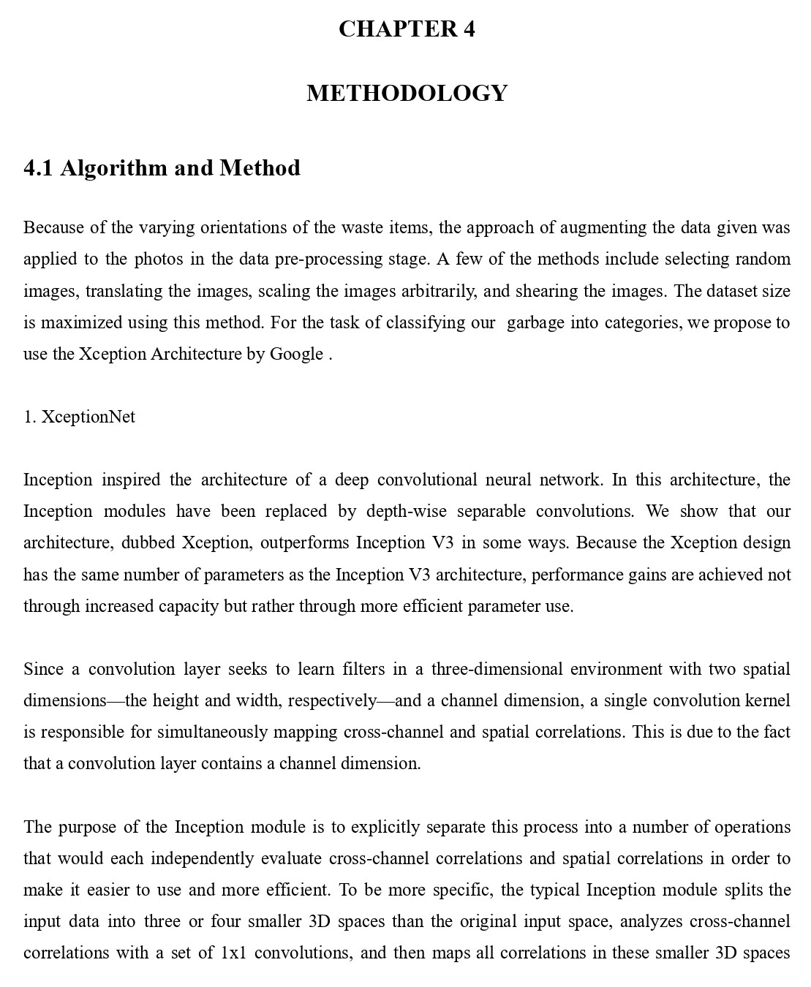

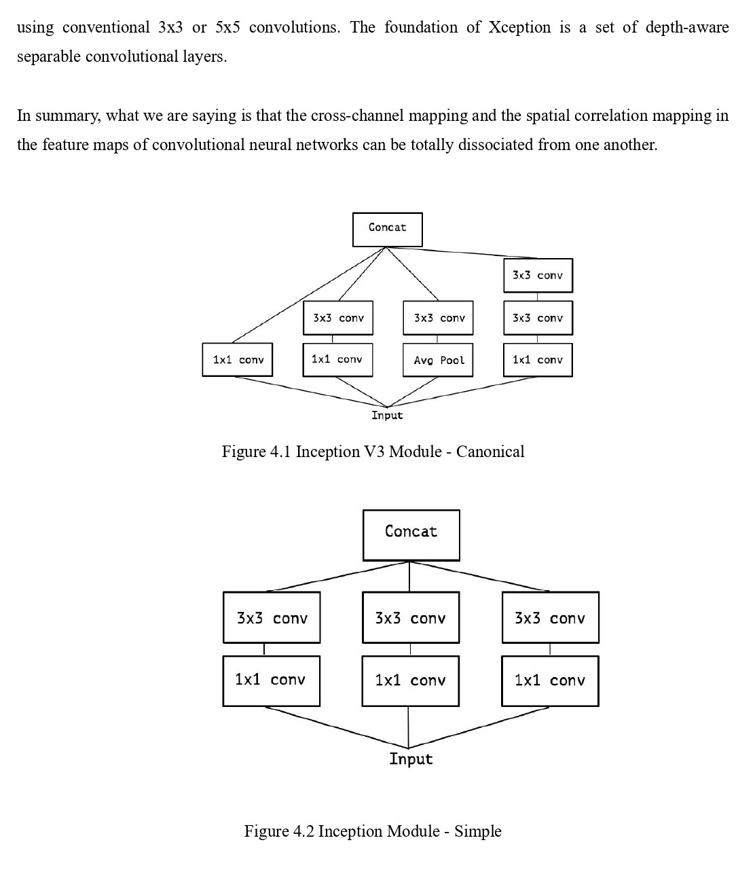

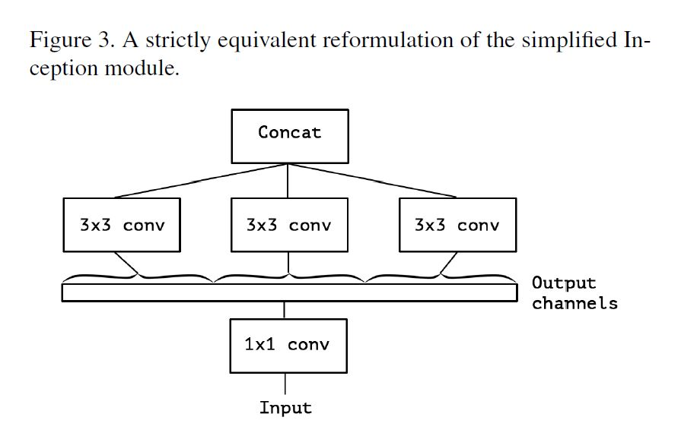

Figure 4.3 A formulation that is identical to the InceptionNet- Simple

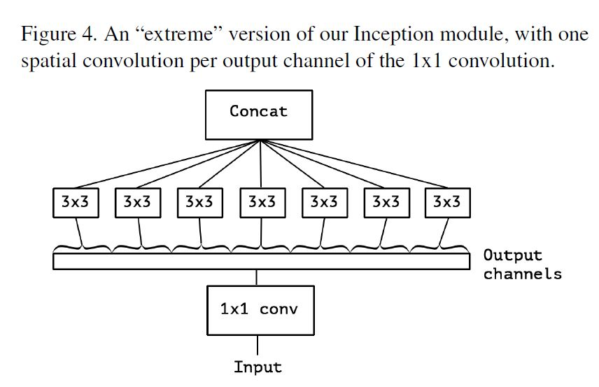

Figure 4.4 An "extreme" variant of our Inception Net

The data first crosses the input flow, then the duplicated eight-times center flow, and finally the exit flow. Noting that each Convolution and Separable Convolution layer is followed by batch normalization. Each layer of Separable Convolution has a depth multiplicator of 1.

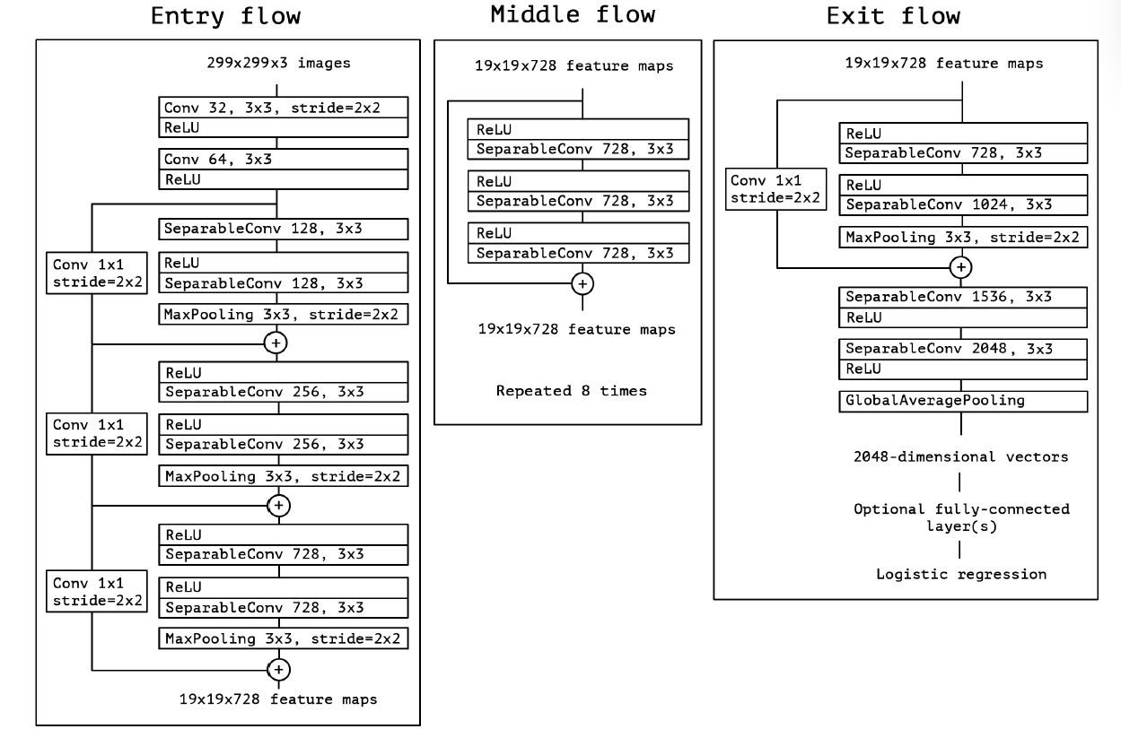

Figure 4.5 The Xception architecture

**4.2 Implementation**

The process of image classification involves the following steps:

* Data collection and preprocessing: This involves collecting a dataset of labeled images and preprocessing them to ensure consistency and remove noise.
* Model training: This involves training a deep learning model, such as a CNN, on the labeled dataset using an optimization algorithm, such as stochastic gradient descent (SGD), to minimize the classification error.
* Model validation and testing: This involves evaluating the performance of the trained model on a validation set and a test set of labeled images to ensure that it can accurately classify new images.
* Model deployment: This involves deploying the trained model to a production environment, where it can be used to classify new images in real-time.

Image classification also has a wide range of applications, including object recognition, face recognition, and medical image analysis.

The mobile application is a portable and simple method for evaluating the efficacy of the strategy and enabling its deployment in the real world. The application has a user-friendly design and other features that can be used to boost one's understanding of trash segregation. The program is developed using Flutter[15], making it compatible with both Android and iOS devices.

The application consists primarily of a bottom navigation bar that guides the user to four primary pages with distinct functionality. These are the available tabs:

* Home
* Tips
* Classify
* FAQs

*A. Home*

The home page is the page that loads when the application is launched. This page provides the user with vital information on waste segregation, educating them on the significance of waste segregation and the advantages of good waste segregation.

*B.Tips*

This page provides information on the various sorts of waste that exist, as well as an explanation of the various methods by which one can dispose of the aforementioned waste categories. It includes information that is particular to the five different forms of waste, which are dry waste, wet waste, hazardous waste, electronic waste, and biological waste.

*C.Classify*

This is the most important page on the application as it performs the function of getting the image that has to be classified and runs it onto the model proposed above and displays the results to the user. The image that has to be sent can either be clicked directly within the app or any image present on the device can also be used for this purpose. The app runs a local Tflite file in the backend to produce the results and reduce the time and resources that are required by cloud-based solutions.

*D.FAQs*

This page consists of the common questions that users of the application may have while segregating waste on their own. This page has in-depth explanations of some of the questions that might be asked by a user that wants to know more about waste management.

The application makes use of various flutter plugins that aid in the process of working the app by performing important functions that otherwise would have been very difficult to perform. Flutter plugins are packages that provide additional functionality or access to native platform features that are not available in the core Flutter framework. Plugins are designed to make it easier for developers to integrate platform-specific features into their Flutter apps without having to write platform-specific code.

There are a wide variety of Flutter plugins available, including plugins for accessing device sensors, accessing platform-specific APIs, integrating with third-party services, and more.

The plugins are as follows:

* [16]google_fonts: ^3.0.1
* [17]just_audio: ^0.9.30
* [18]url_launcher: ^6.1.6
* [19]carousel_slider: ^4.1.1
* [20]image_picker: ^0.8.6
* [21]flutter_tflite: ^1.0.1
* [22]font_awesome_flutter: ^10.2.1

**CHAPTER 5**

**CODING AND TESTING**

1. Mobile Application Code - Main

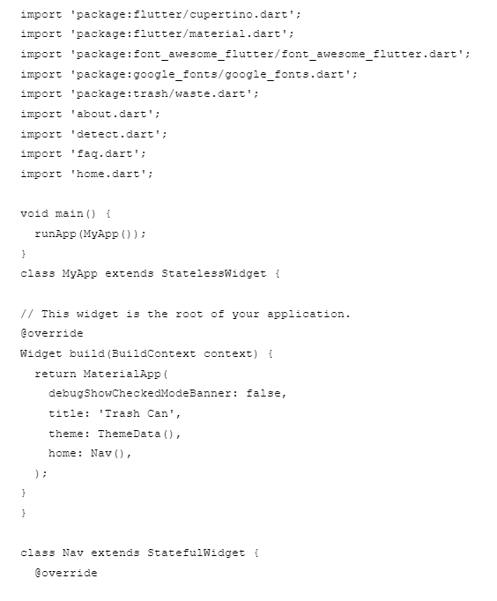

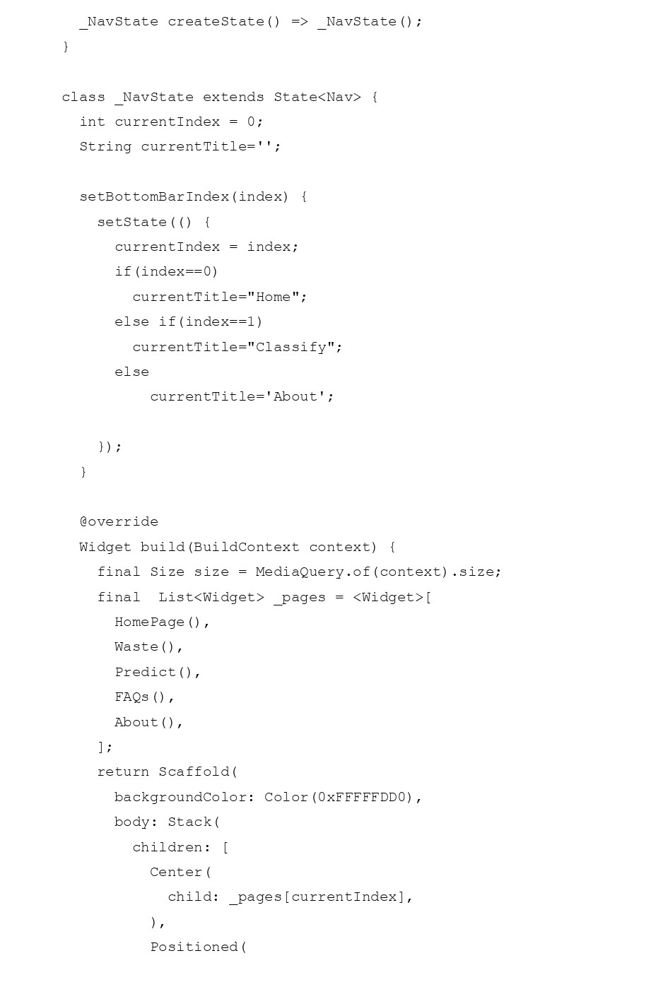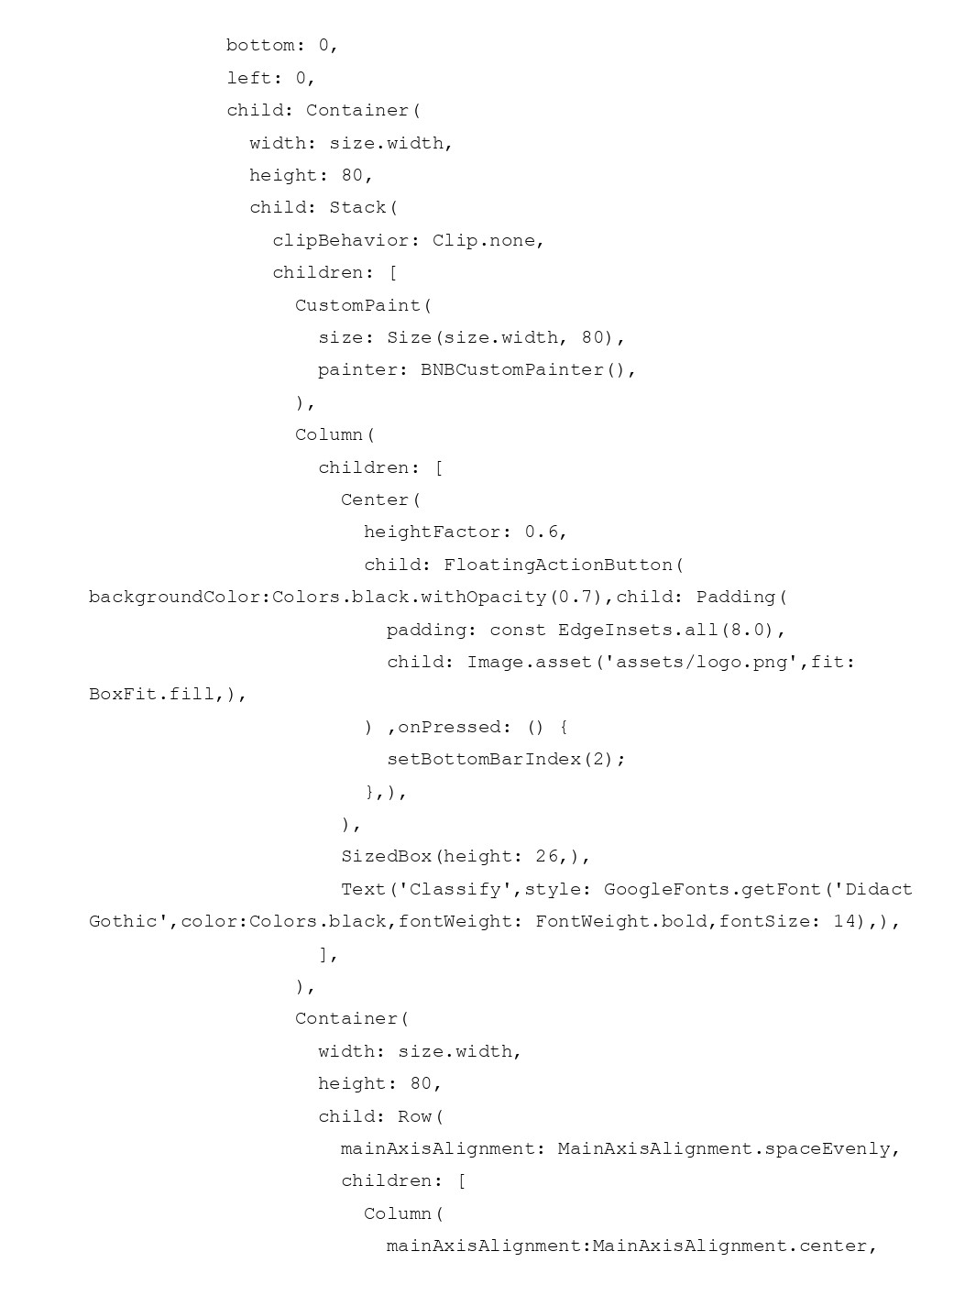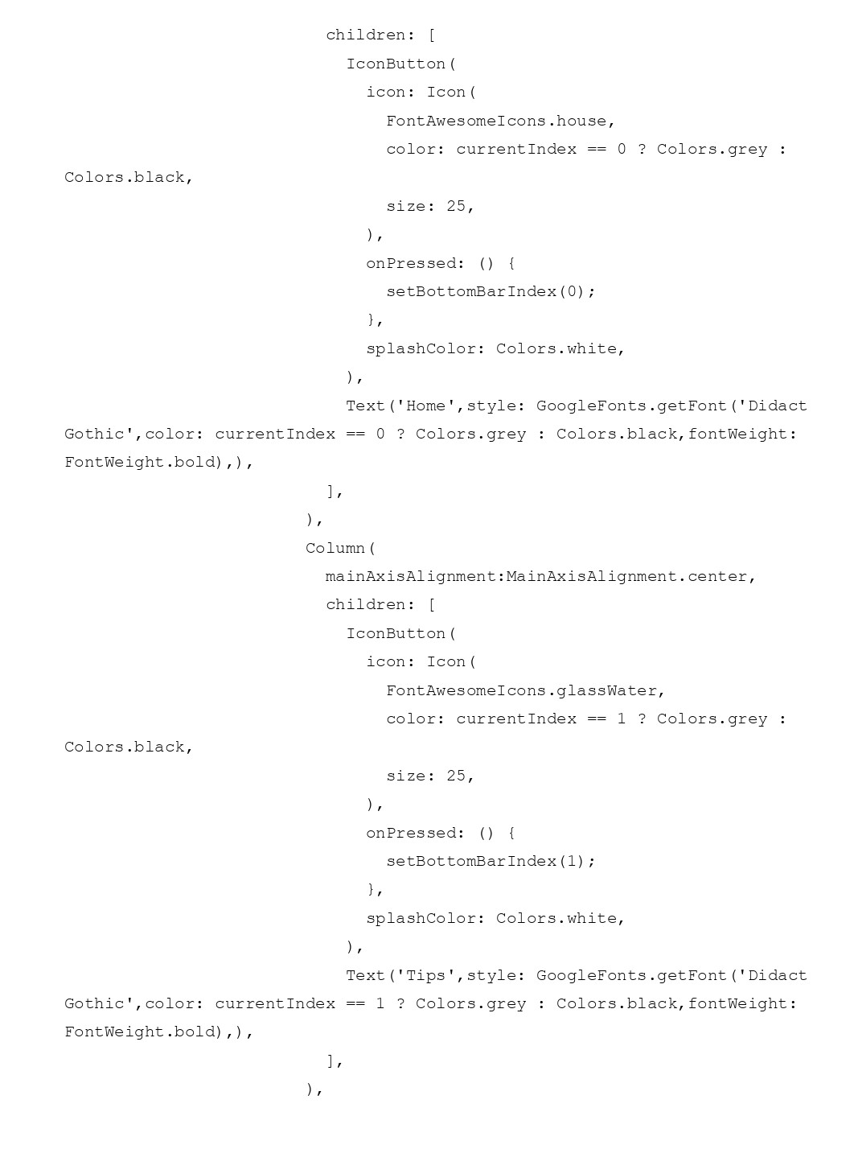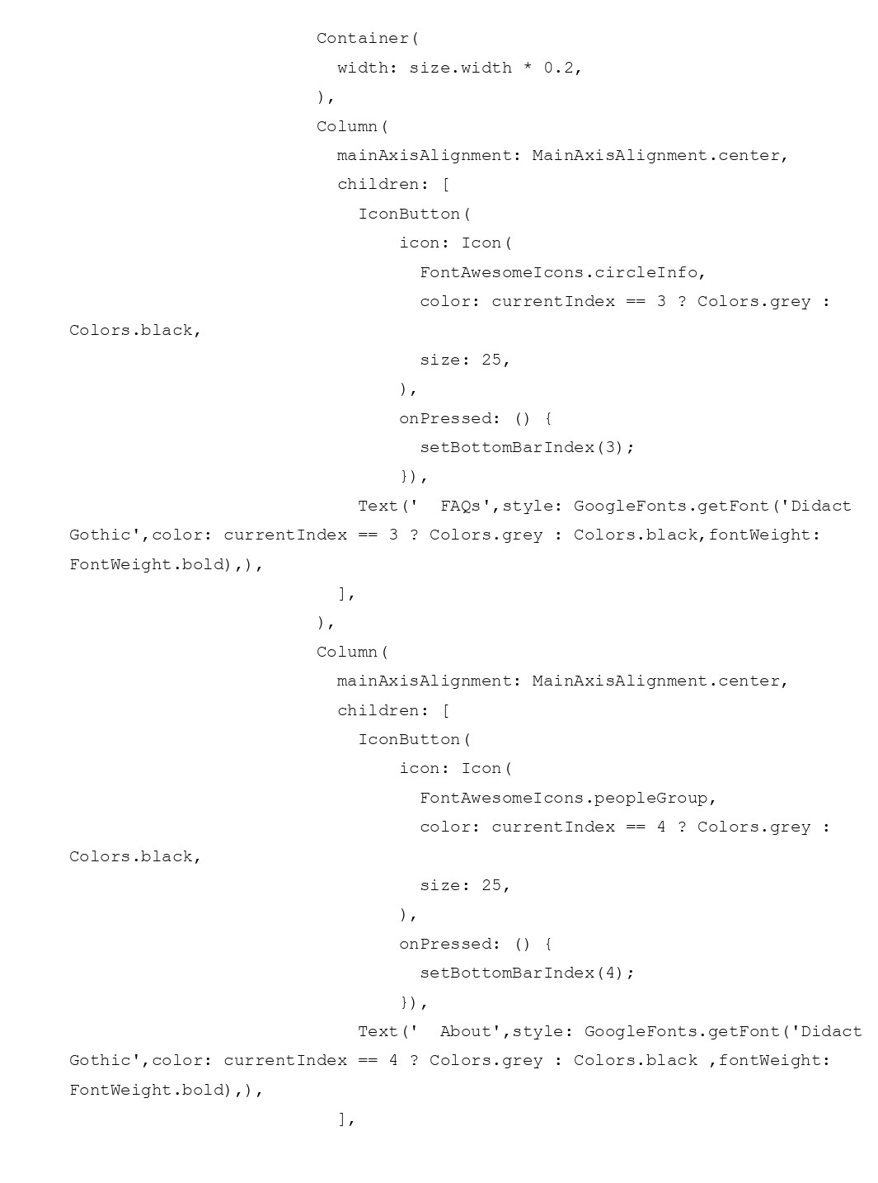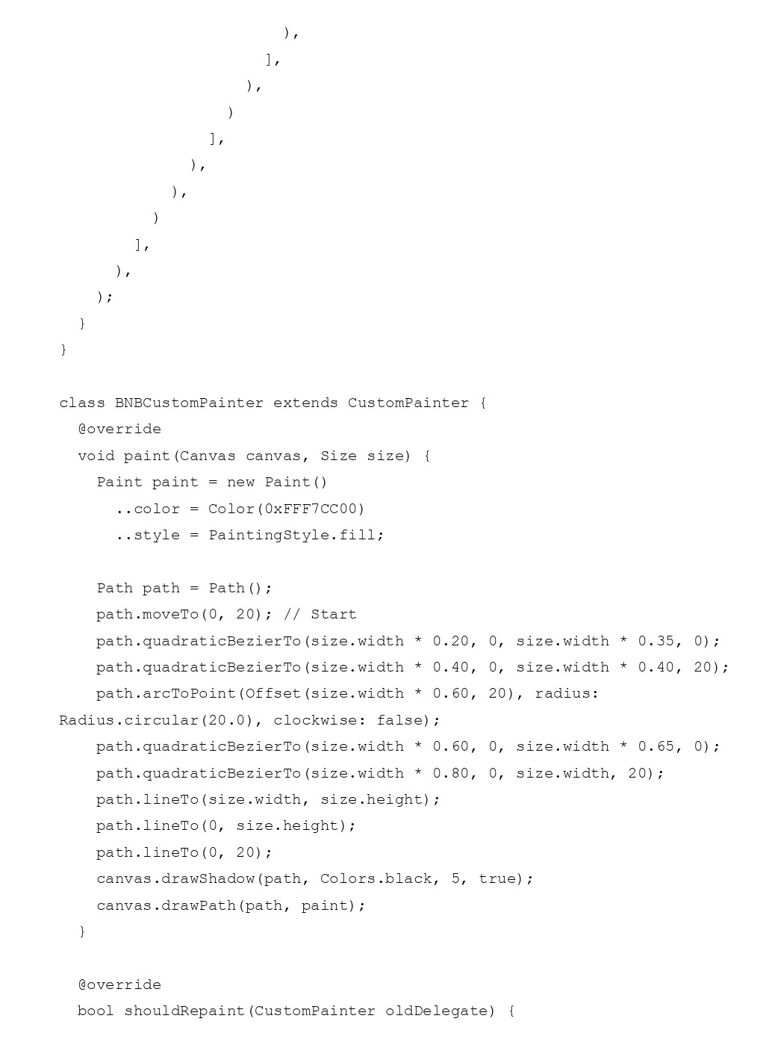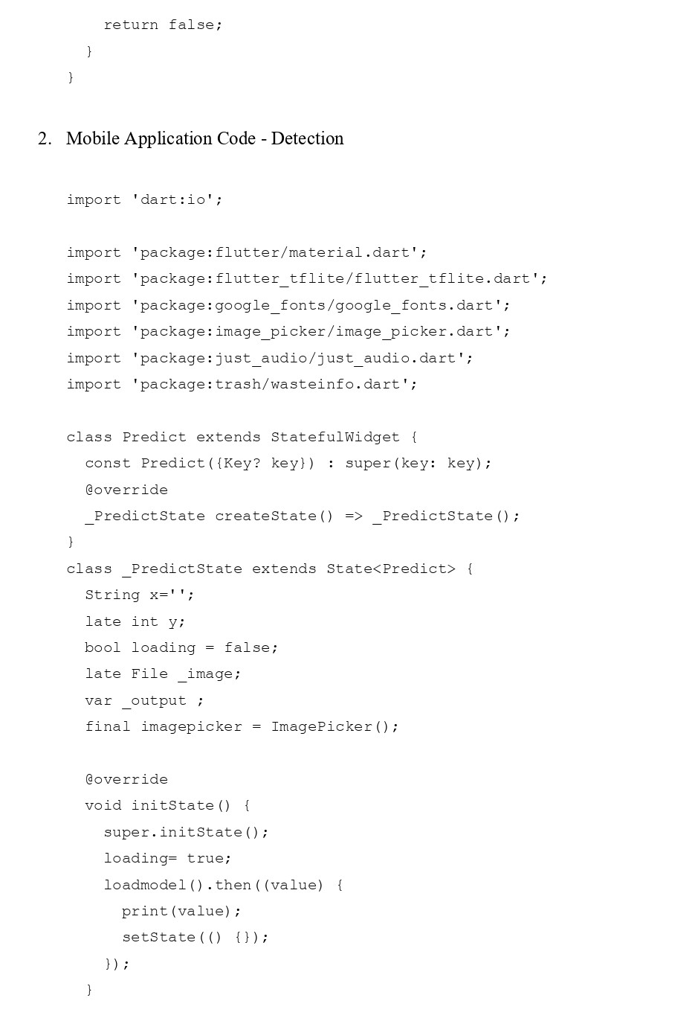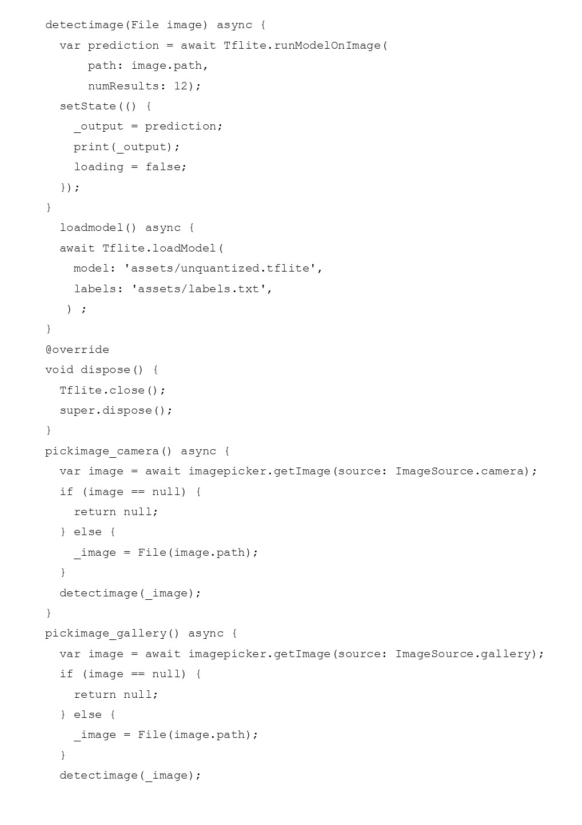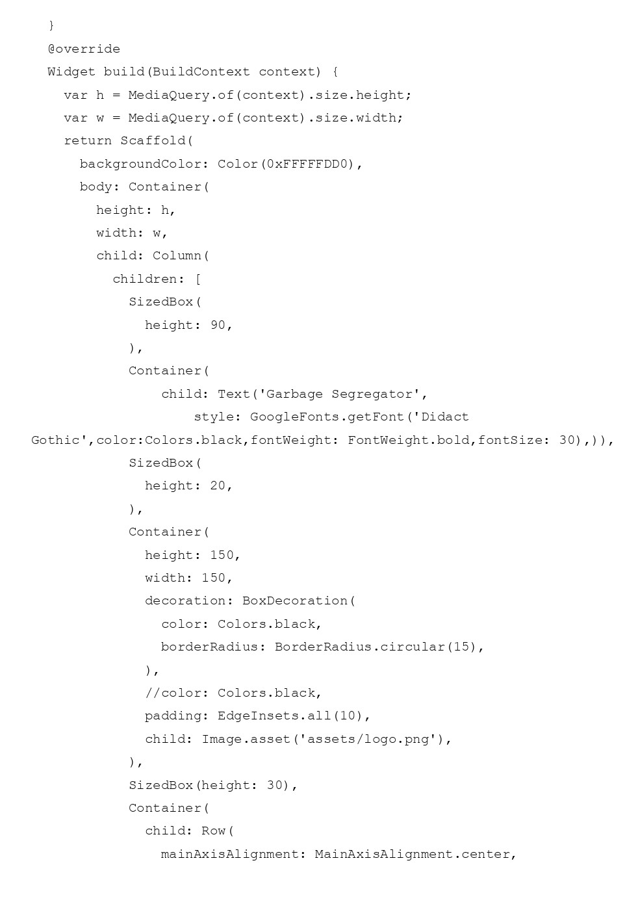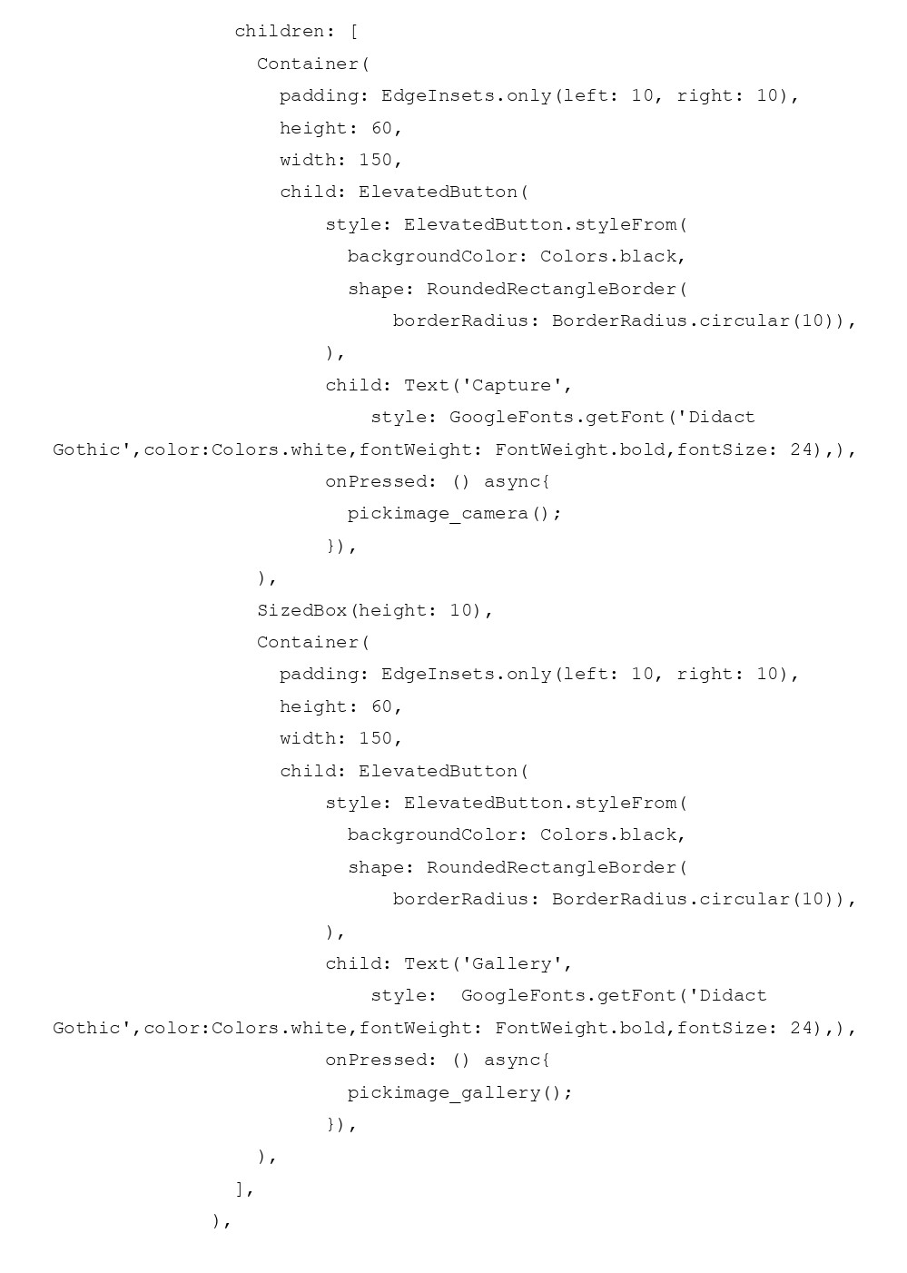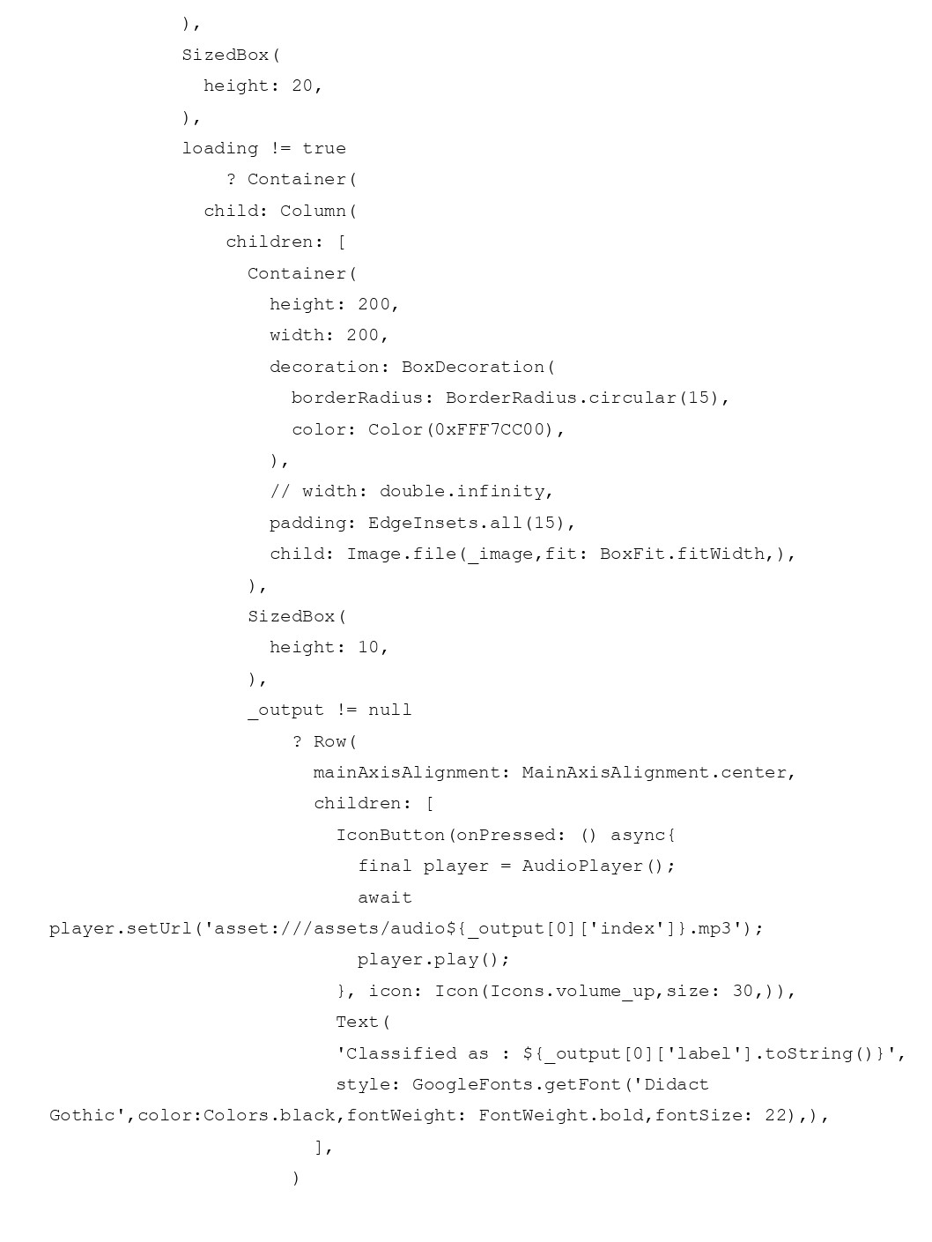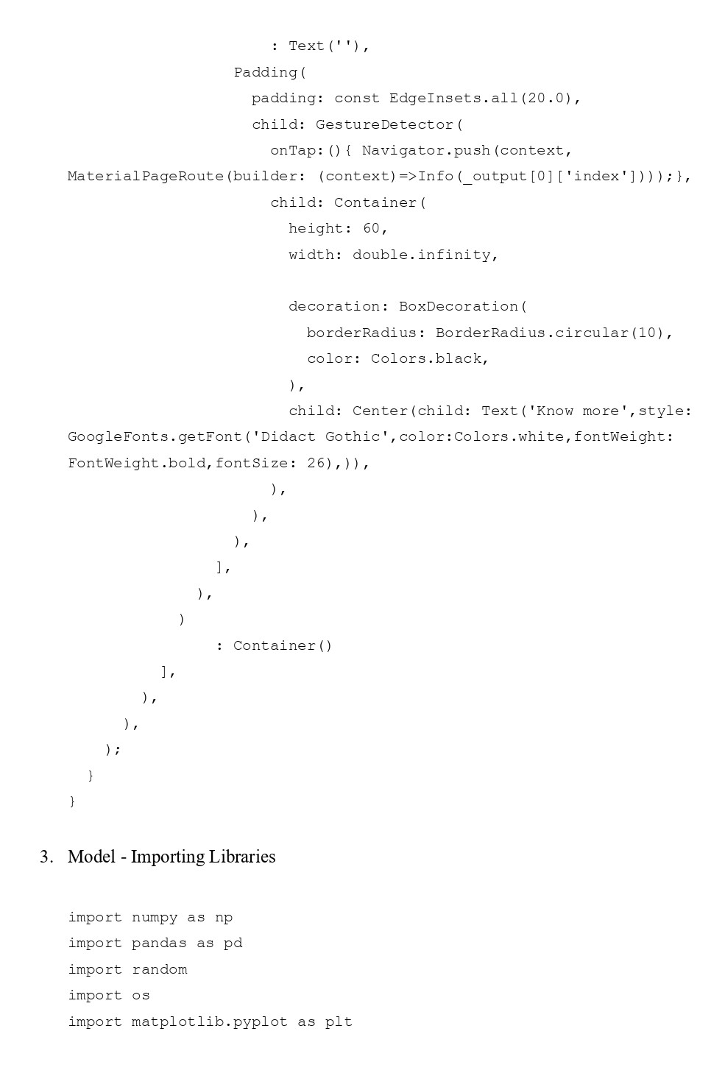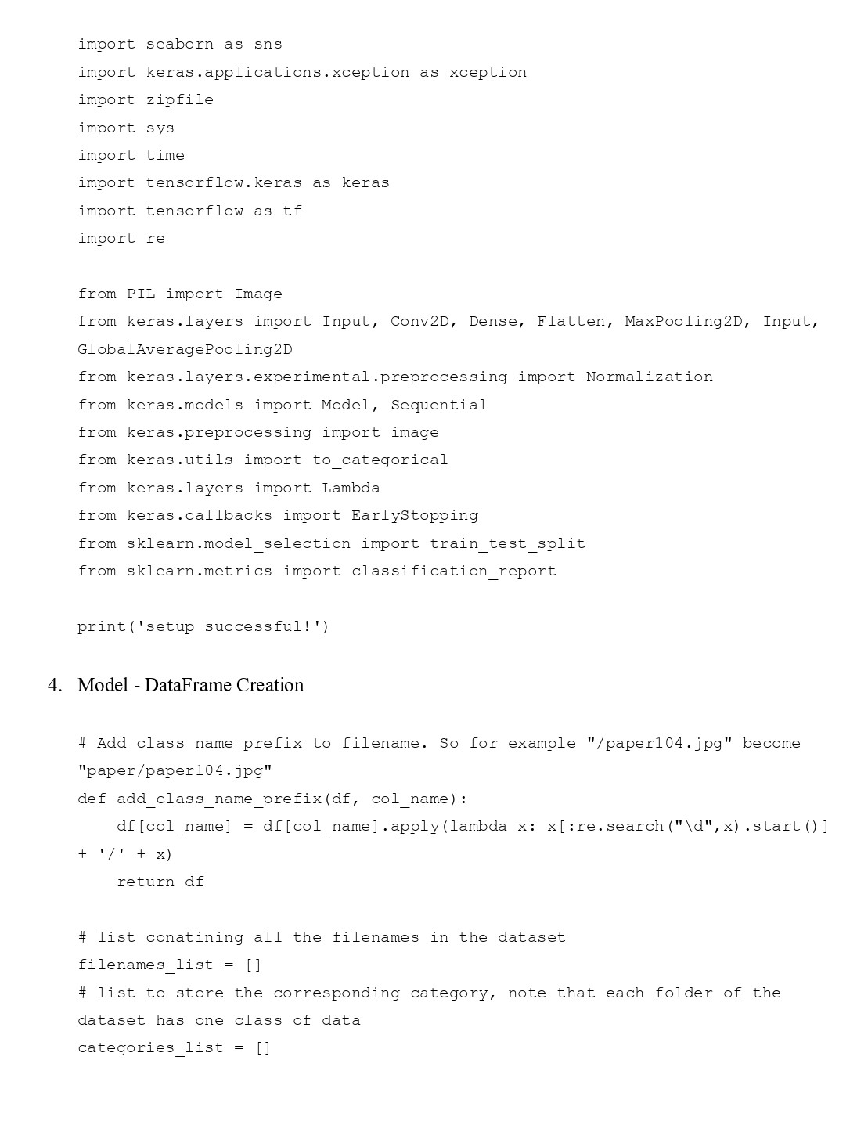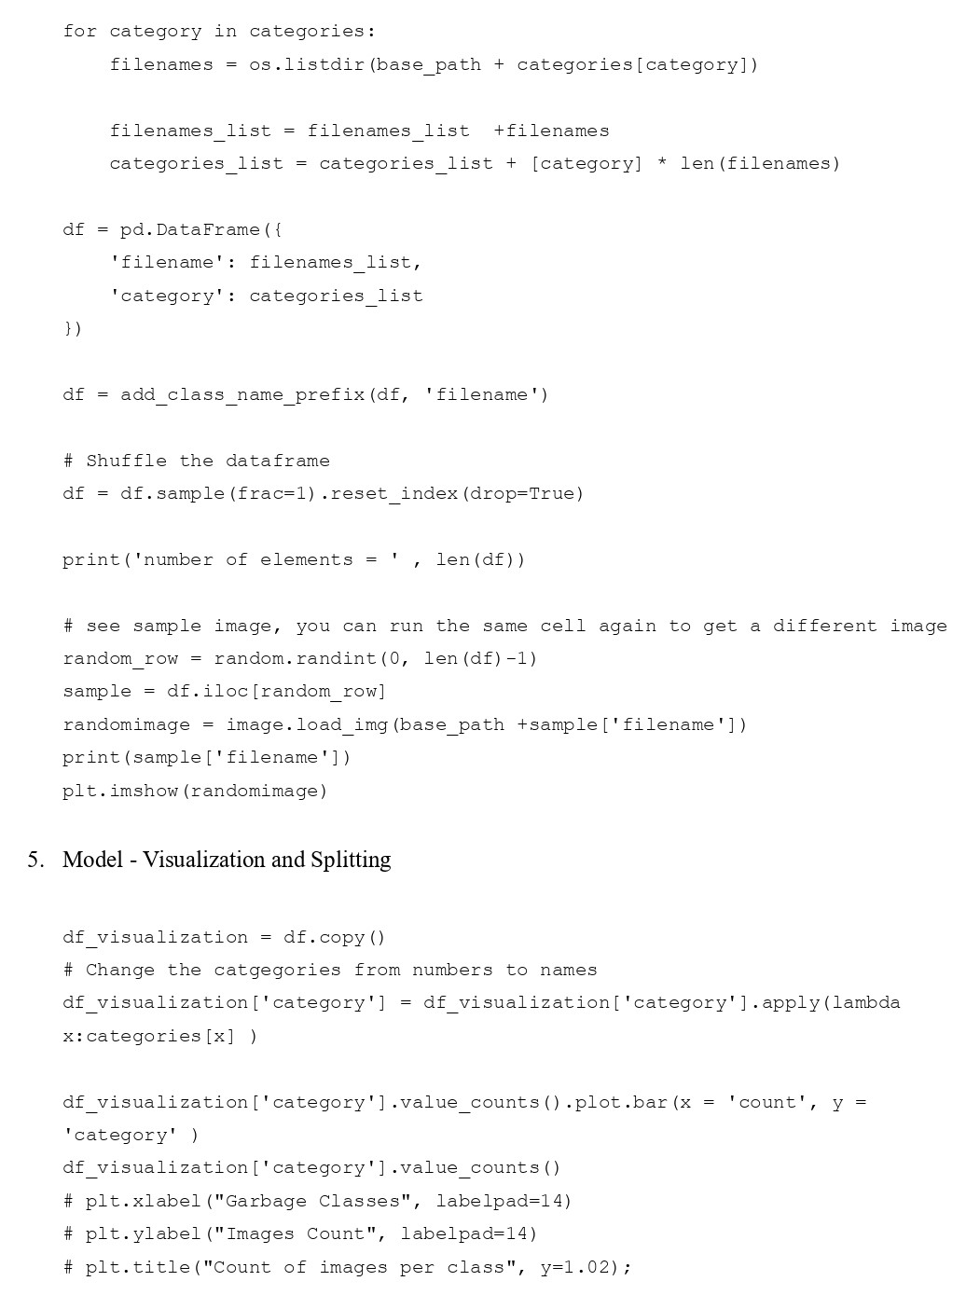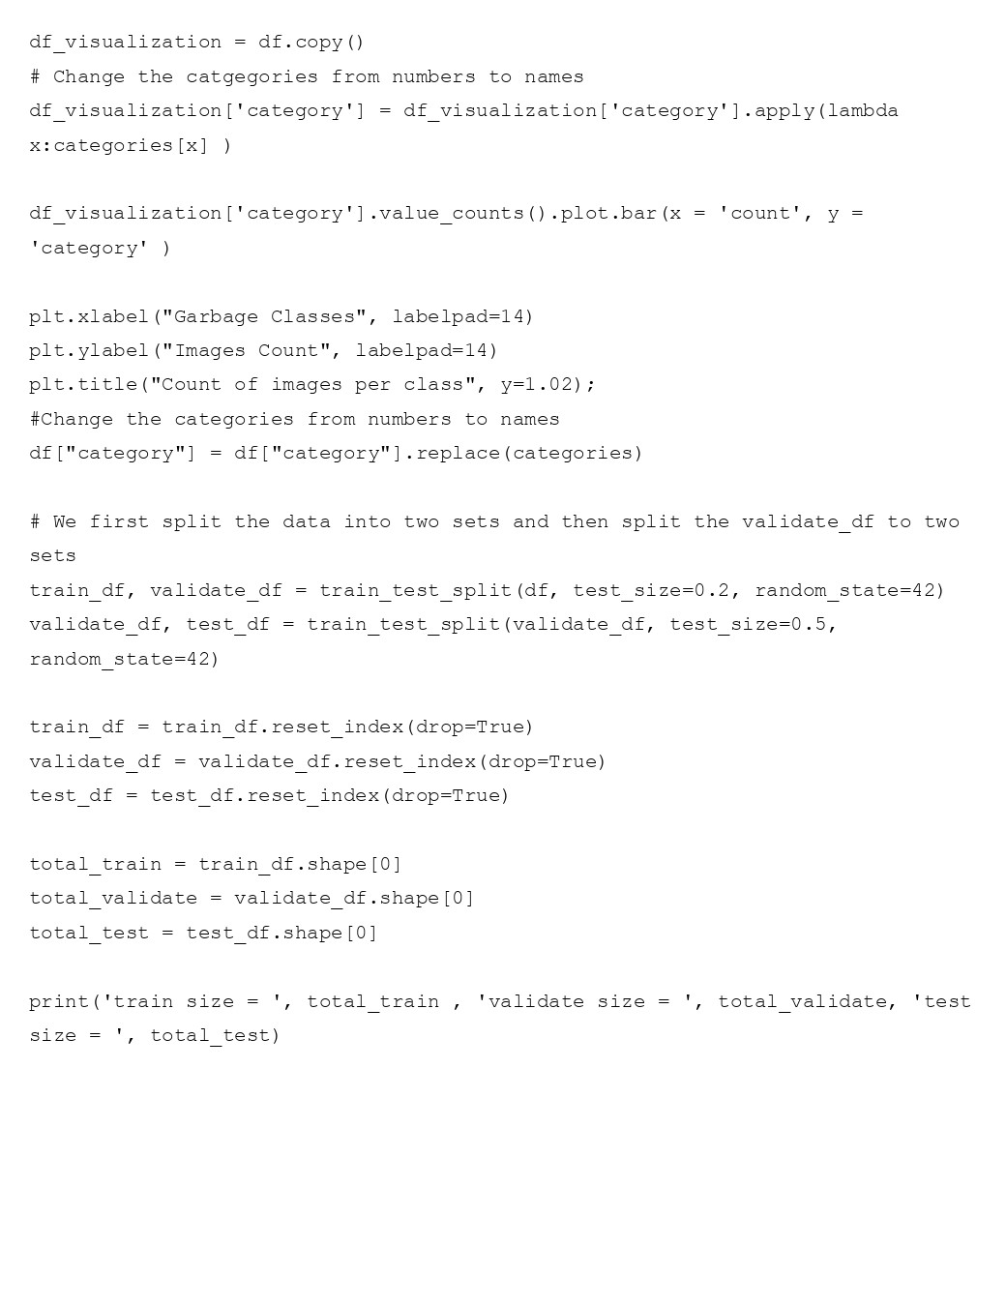**CHAPTER 6**

**RESULTS AND DISCUSSIONS**

**6.1 Model and Accuracy**

On the Kaggle platform, Keras library and TensorFlow version 2.1.4 were used for all of the experiments in this work [14]. Using GPU P100, the trials were carried out. We employed weights, training data, completely new training models, validation during training, and training models for the studies.

The batch size and epoch count in the suggested model were both set to 64 and 20, respectively, but it was found that after epoch number 7, the model's accuracy did not increase. As a result, an early halting technique was used, and an accuracy of 94.91% was achieved. The test loss became stagnant at a same value and stopped decreasing further, which is the need for terminating after the seventh epoch.

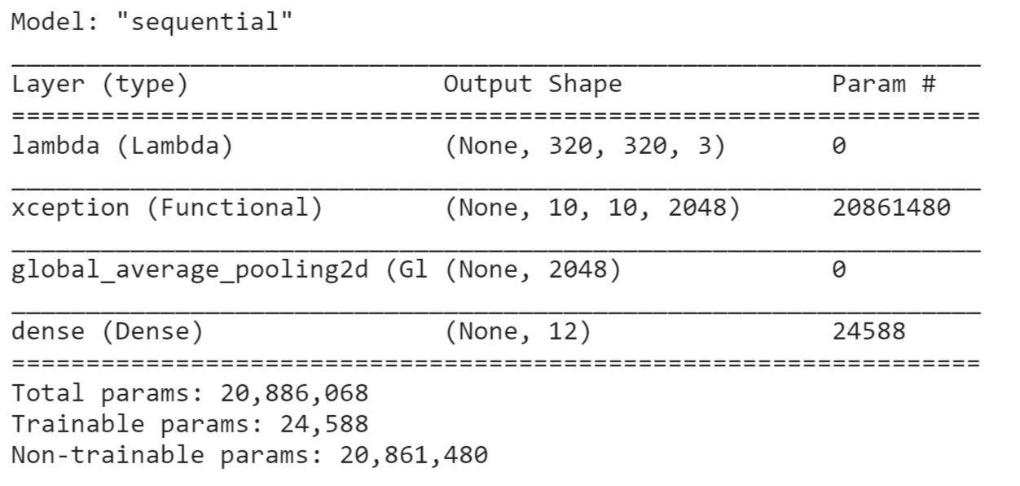

Figure 6.1 Model Structure

To compute accuracy, we accounted for the following parameters, which helped make our successful implementation precise -

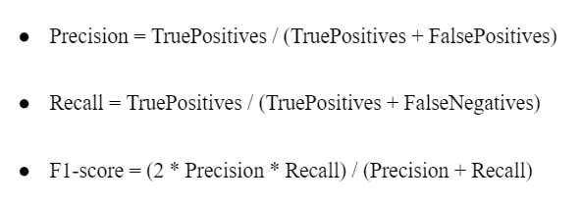

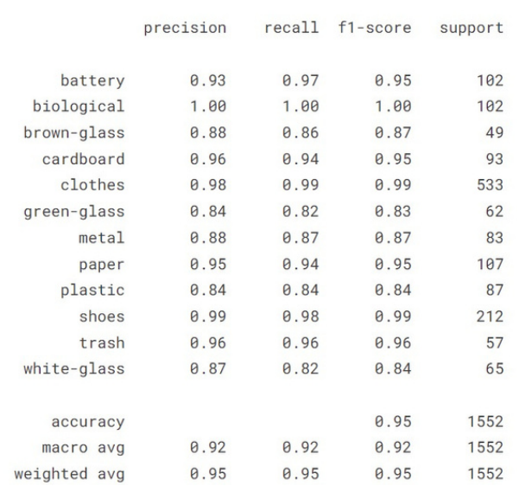

Table 6.1 Accuracy Matrix

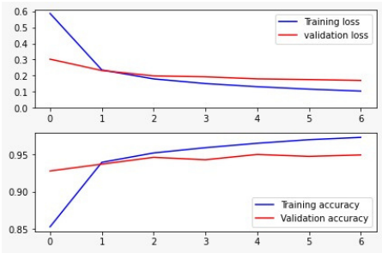

Figure 6.2 Accuracy and Loss Graph

**6.2 Output Screenshots**

1. Dataset Sample

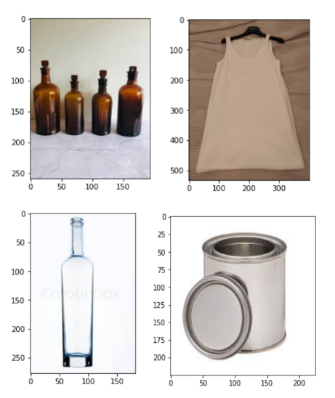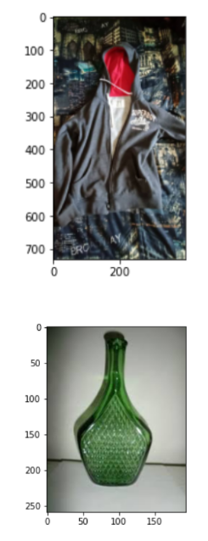

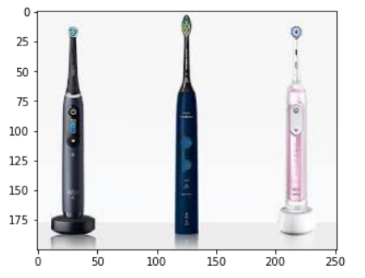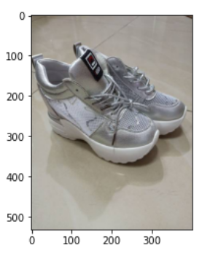

1. Mobile Application

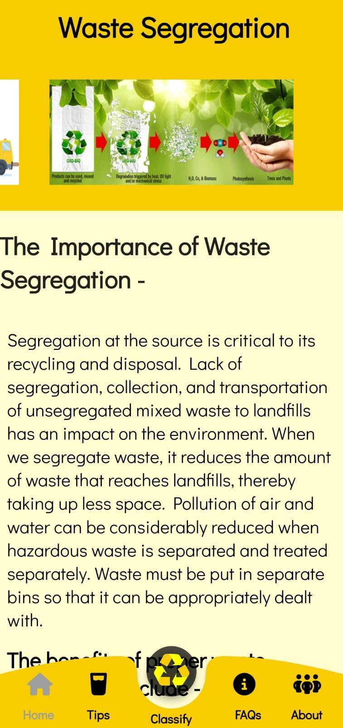 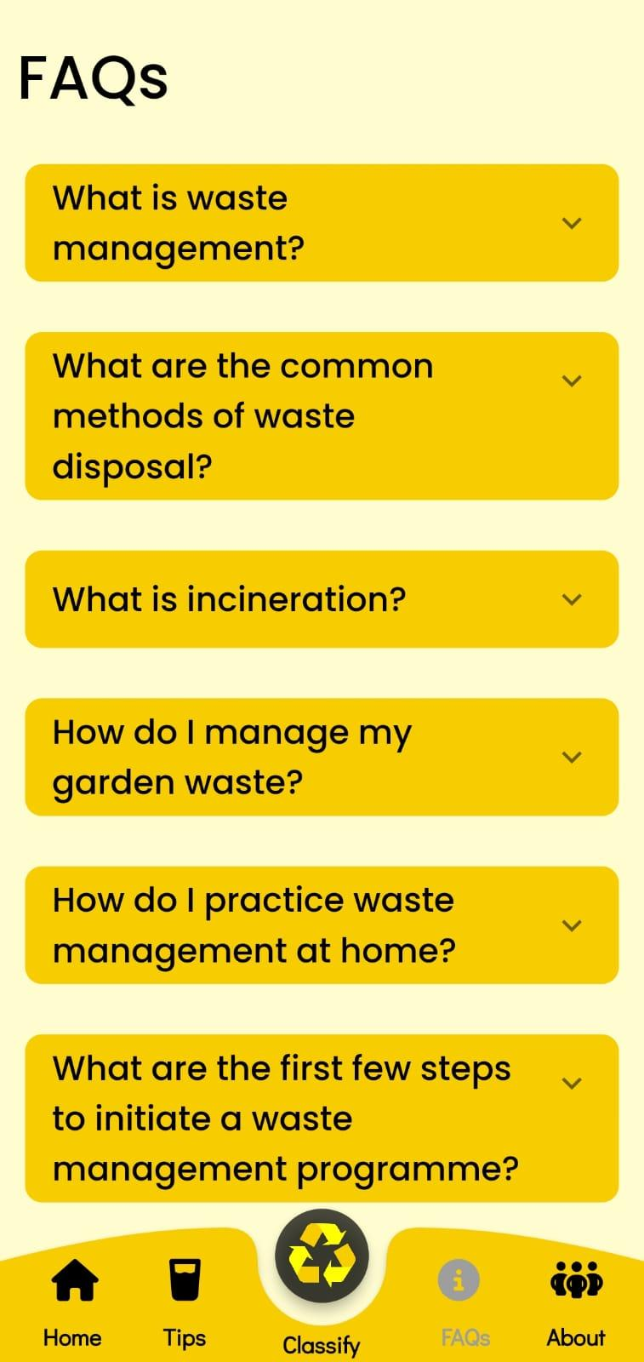

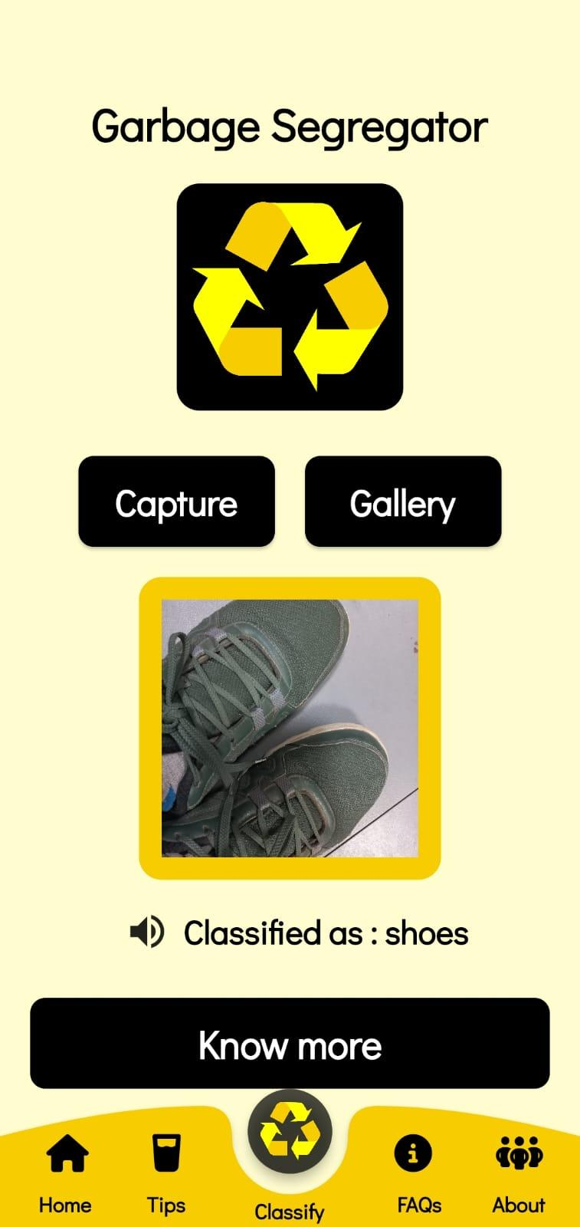 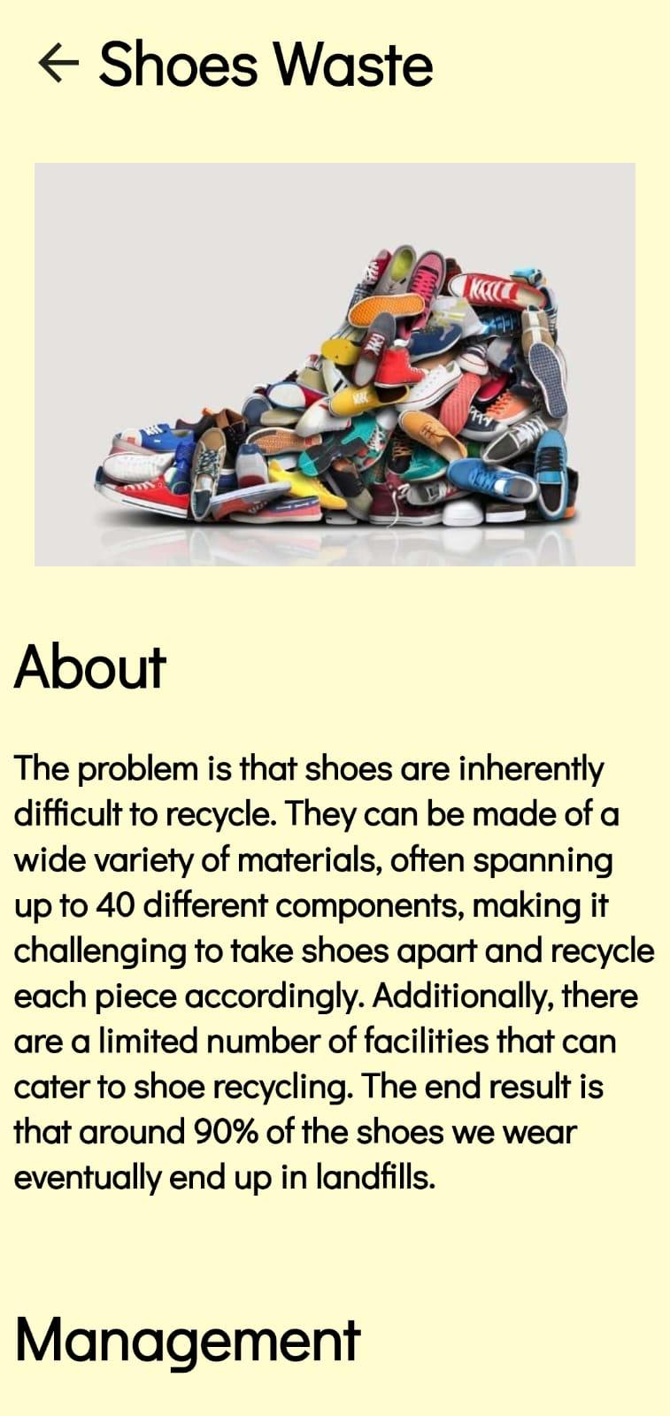

**CHAPTER 7**

**CONCLUSION AND FUTURE ENHANCEMENTS**

To make garbage separation less onerous, we suggested a method of classifying waste into different categories. We also made this method accessible to regular users so they could use it to separate waste at the source. The earlier model uses the Xception model to accomplish this feat and has an accuracy that fluctuates randomly between 94 and 96 percent.

The current work integrates MobileNet model completely based on cloud, increasing the dynamics of our application while also keeping a check on the accuracy of our work, Moreover, the multi-class output generation provided a major breakthrough in our study and hoping it to produce same results that were benchmarked by our previous single class based outputs.

We also intend to enhance the dataset by including more recent photos, hence enhancing the model's precision. In addition, we want to add data in such a way as to lessen the highly skewed data set and make it more uniformly distributed.

**REFERENCES**

1. Trends in Solid Waste Management - <https://datatopics.worldbank.org/what-a-waste/trends_in_solid_waste_management.html>
2. Intelligent Waste Classification System Using Deep Learning Convolutional Neural Network - Olugboja Adedeji, Zenghui Wang
3. A Method for Waste Segregation using Convolutional Neural Networks - Jash shah, Sagar Kamat
4. Xception: Deep Learning with Depthwise Separable Convolutions - Francois Chollet(Google Inc)
5. J. Donovan, “Auto-trash sorts garbage automatically at the techcrunch disrupt hackathon.” [Online]. Available: <https://techcrunch.com/2016/09/13/auto-trash-sortsgarbageautomatically-at-the-techcrunch-disrupt-hackathon/>
6. G. Mittal, K. B. Yagnik, M. Garg, and N. C. Krishnan, “Spotgarbage: Smartphone app to detect garbage using deep learning,” in Proceedings of the 2016 ACM International Joint Conference on Pervasive and Ubiquitous Computing, ser. UbiComp ’16. New York, NY, USA: ACM, pp. 940–945, 2016. [Online]. Available: <http://doi.acm.org/10.1145/2971648.2971731>
7. S. Meng and W. -T. Chu, ”A Study of Garbage Classification with Convolutional Neural Networks,” 2020 Indo – Taiwan 2nd International Conference on Computing, Analytics and Networks (Indo-Taiwan ICAN), 2020, pp. 152-157, doi: 10.1109/Indo-TaiwanICAN48429.2020.9181311.
8. Ziouzios, D.; Tsiktsiris, D.; Baras, N.; Dasygenis, M. A Distributed Architecture for Smart Recycling Using Machine Learning. Future Internet 2020, 12, 141. <https://doi.org/10.3390/fi12090141>
9. Gao, M.; Qi, D.; Mu, H.; Chen, J. A Transfer Residual Neural Network Based on ResNet-34 for Detection of Wood Knot Defects. Forests 2021, 12, 212. <https://doi.org/10.3390/f12020212>
10. K. He, X. Zhang, S. Ren and J. Sun, “Deep Residual Learning for Image Recognition,” in CVPR, 2016.
11. Youpeng Yu, , and Ryan Grammenos. ”Towards artificially intelligent recycling Improving image processing for waste classification.”, arXiv:2108.06274 [cs.CV],(2021).
12. https://www.kaggle.com/datasets/mostafaabla/garbage-classification
13. Inception-v4, Inception-ResNet and the Impact of Residual Connections on Learning: <https://arxiv.org/abs/1602.07261>
14. Kaggle: https://www.kaggle.com/
15. Flutter: https://flutter.dev/
16. Google Fonts: https://pub.dev/packages/google_fonts
17. Just Audio: https://pub.dev/packages/just_audio
18. URL Launcher: https://pub.dev/packages/url_launcher
19. Carousel Slider: https://pub.dev/packages/carousel_slider
20. Image Picker: https://pub.dev/packages/image_picker
21. Flutter Tflite: https://pub.dev/packages/flutter_tflite
22. Font Awesome: <https://pub.dev/packages/font_awesome_flutter>
23. Trash Classification Using Convolutional Neural Networks, Project Category: Computer Vision - Yujie He,Qinyue Gu,Maguo Shi
24. A deep learning approach based hardware solution to categorize garbage in an environment - Tanya Gupta · Rakshit Joshi· Devarshi Mukhopadhyay · Kartik Sachdeva · Nikita Jain1 · Deepali Virmani Laura Garcia-Hernandez
25. Waste Segregation Using Deep Learning - Meena. U, Shailaja. R, Swanit.R, Prajakta.P
26. Classification of TrashNet Dataset Based on Deep Learning Models : Rahmi Arda Aral; Şeref Recep Keskin; Mahmut Kaya; Murat Hacıömeroğlu
27. Classification of Trash for Recyclability Status: Mindy Yang, Gary Thung
28. S. Albawi, T. A. Mohammed and S. Al-Zawi, ”Understanding of a convolutional neural network,” 2017 International Conference on Engineering and Technology (ICET), 2017, pp. 1-6, doi: 10.1109/ICEngTech-nol.2017.8308186
29. K. Ahmad, K. Khan, and A. Al-Fuqaha, ”Intelligent Fusion of Deep Features for Improved Waste Classification,” in IEEE Access, vol. 8, pp. 96495-96504, 2020, doi: 10.1109/ACCESS.2020.2995681

**APPENDIX A**

**CONFERENCE PUBLICATION**

We presented our paper titled ‘Application to segregate Waste using Deep Learning’ at Chemflux 10.0 in SRM Institute of Science and Technology. Our manuscript ID is ‘CF1006’. We were announced as winners of the event and were awarded the ‘Best Paper Presentation’.

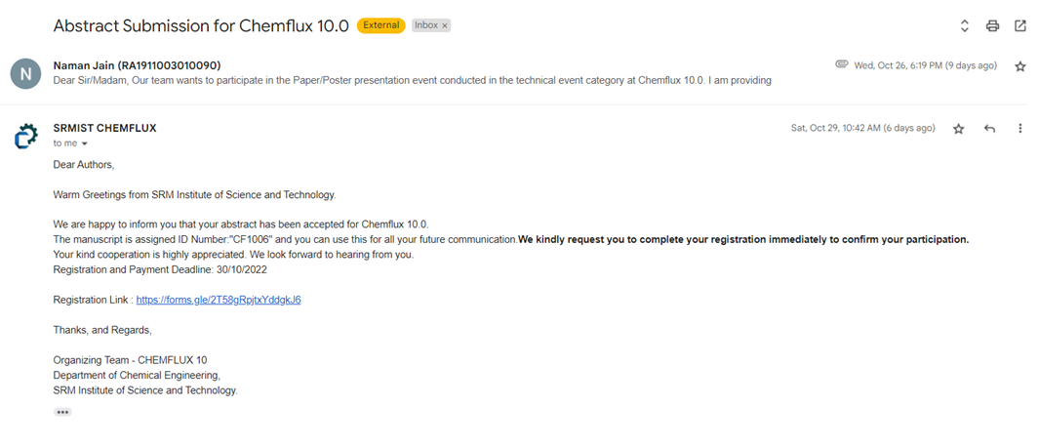

**APPENDIX B**

**PLAGIARISM REPORT**